ENROLMENT FORM
Italian Summer Course 2011

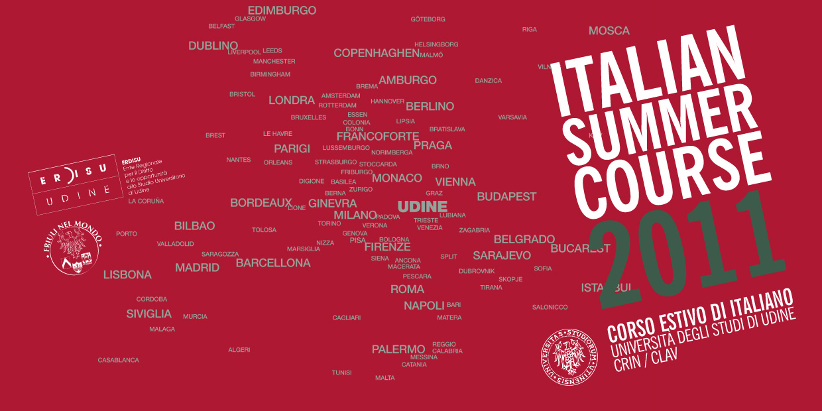

Name: _____________________________
Surname: __________________________

Please, fill in the form with your computer.

I would like to enrol in the Italian Summer Course:

Surname: _______________________________________________________________________

Name: __________________________________________________________________________

Address: ________________________________________________________________________

Postcode: _______________________________________________________________________

Country: ________________________________________________________________________

Tel: ________________________________ Mobile ______________________________________

Fax: ____________________________________________________________________________

E-mail: __________________________________________________________________________

Level of Italian*: __________________________________________________________________

* ٱ Elementary
ٱ Intermediate
ٱ Advanced

How did you learn of this course?

ٱ Consulate, Embassy, Cultural Institute
ٱ University, School
ٱ Newspapers
ٱ Friends
ٱ Internet

Why are you studying Italian?
................................................................................................................................................................................................................................................................................................................................................................................................................................................

Autorizzo il Centro Rapporti Internazionali a utilizzare i miei dati per gli usi consentiti dalla legge in base alla legge n. 196/03 del 27/06/2003 (tutela delle persone e di altri soggetti rispetto al trattamento dei dati personali).
 SI
 NO

